# HACETTEPE UNIVERSITY DEPARTMENT OF COMPUTER ENGINEERING

**BBM 382 SOFTWARE ENGINEERING**



**Prepared by OKAN ALAN Number : 21526638**

**Subject :UML Assignment**

**Context Diagram**

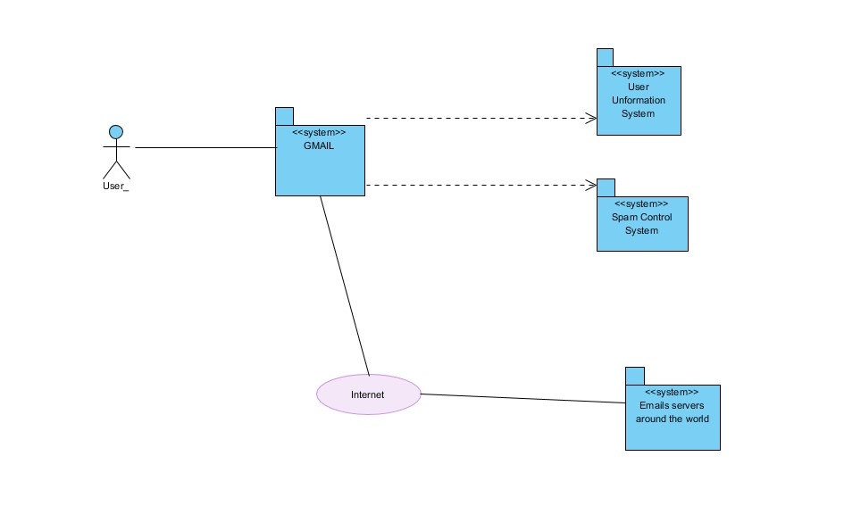

**Use Case Diagram**

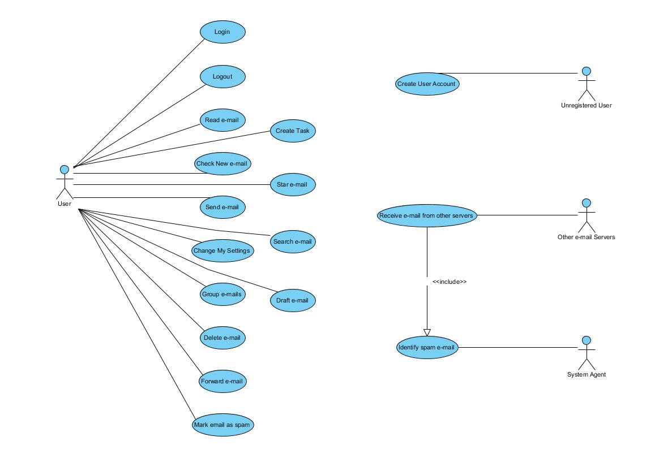

**Activity Diagrams**

**-Login**

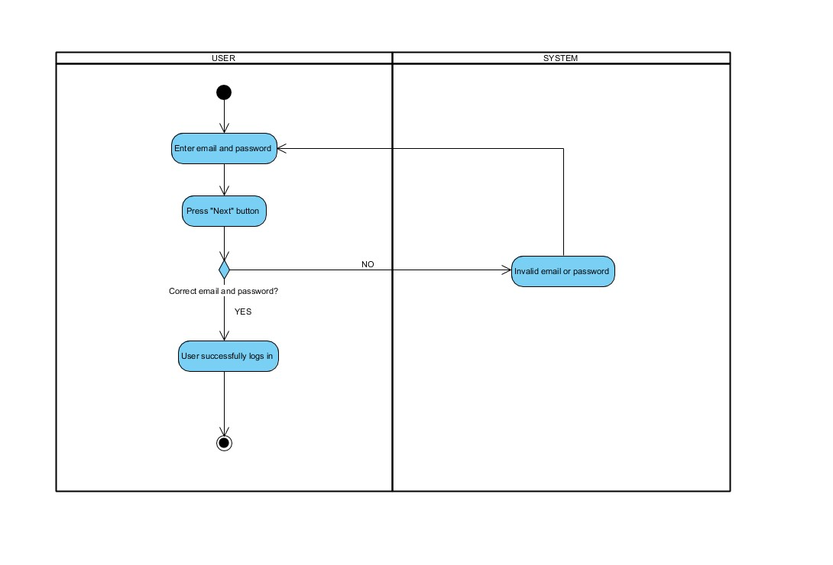

* **Change My Settings**

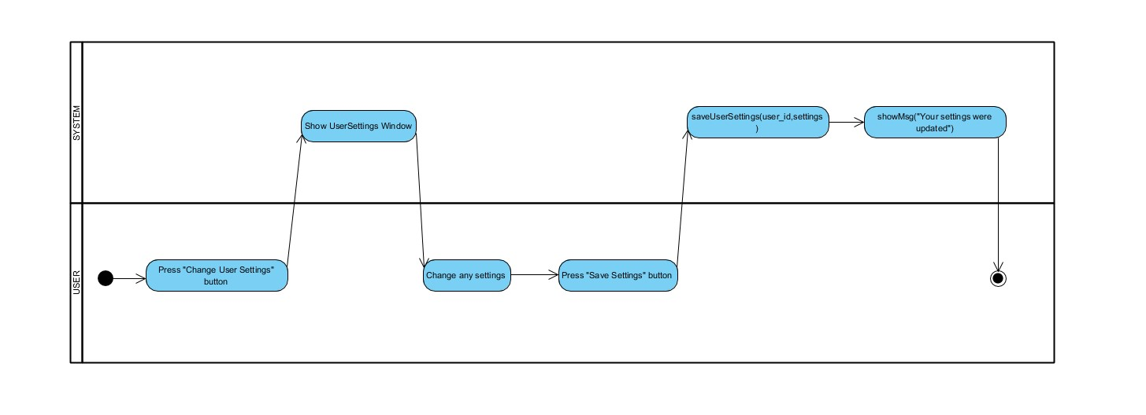

* **Search EMail**

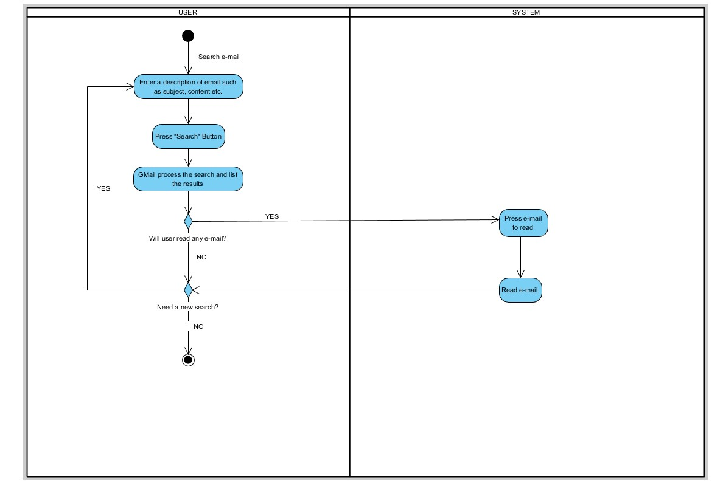

**Class Diagram**

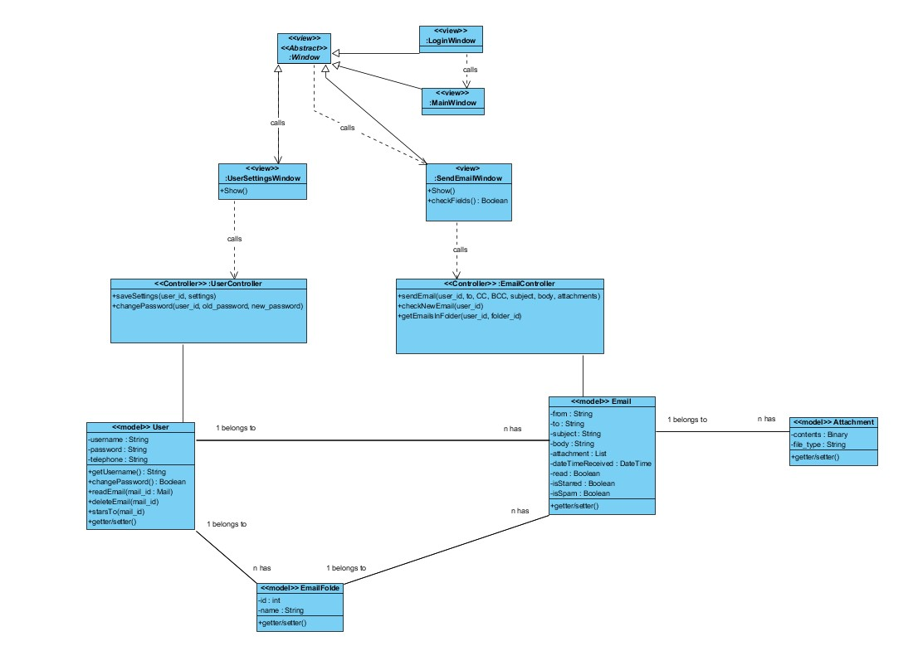

**Sequence Diagrams**

* **Change My Settings**

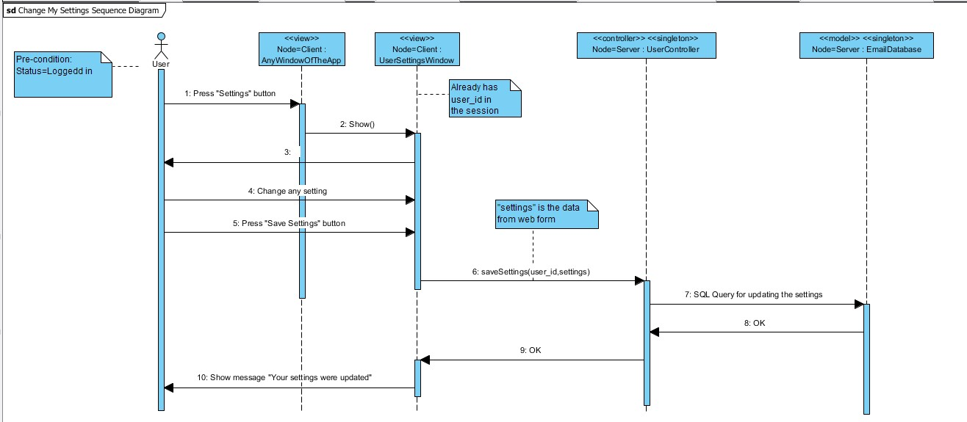

* **Check New Email**

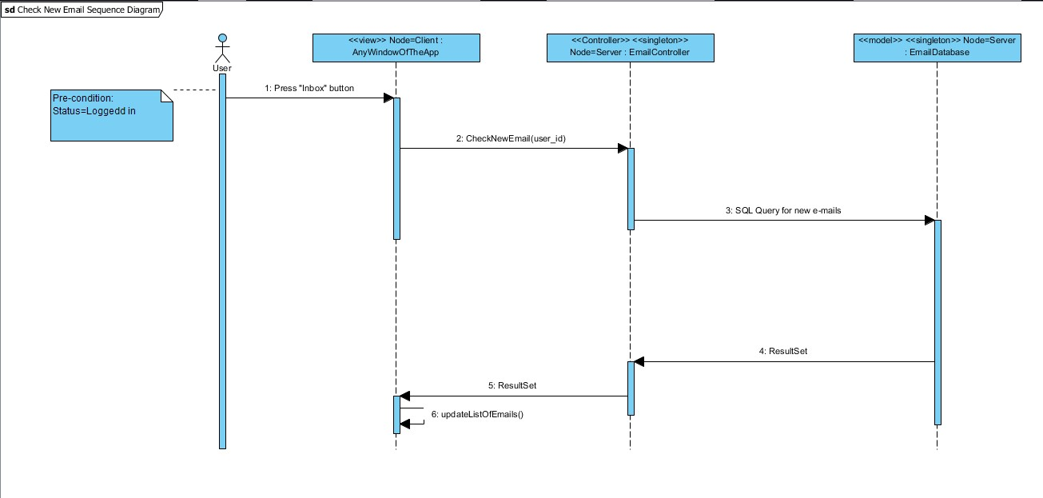

* **Send Email**

